Bash Scripting – 02
- Create a bash script to check if a directory is available or not
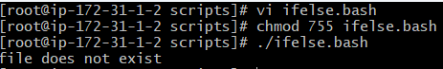
- Create a bash script to create multiple files
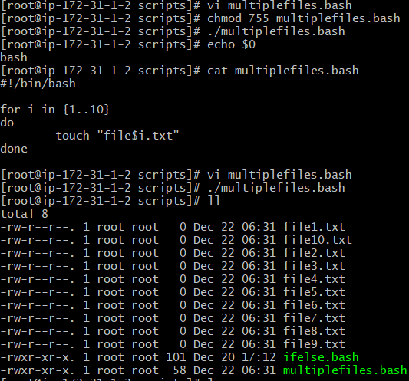
- Create a bash script to take a backup of a directory
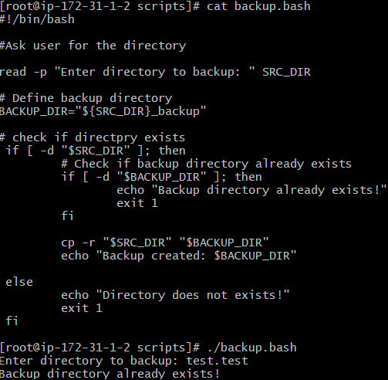
- Create a bash script to install Nginx on an EC2 server
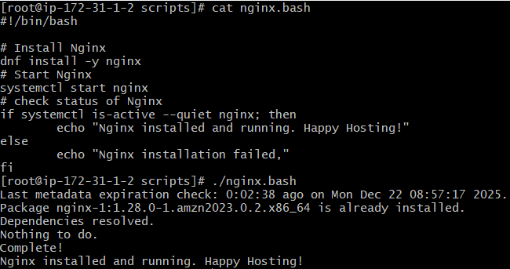
- Create a bash script to install Apache Tomcat on an EC2 server
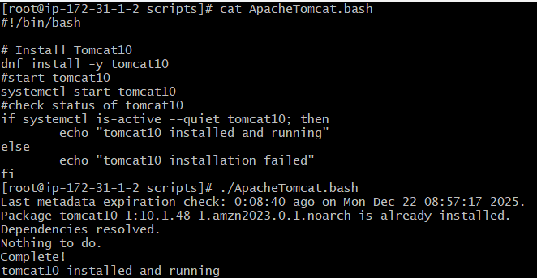
- Create a bash script to check if the Nginx service is running, if not running then script should start the service
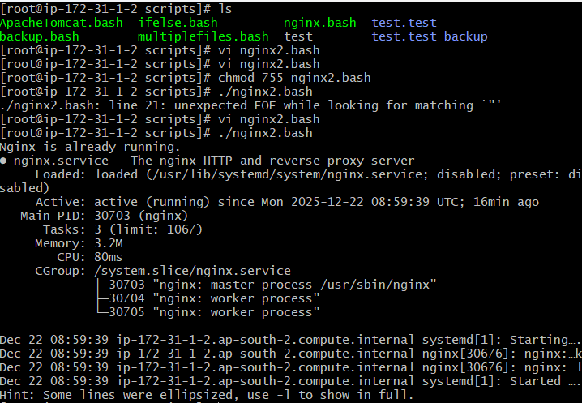
- Create a bash script for a calculator
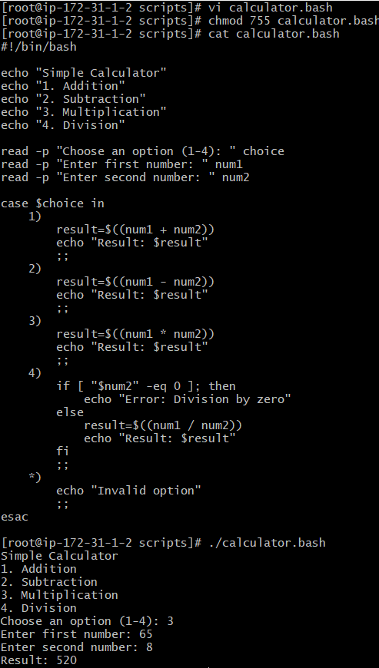
- Create a bash script to check if a directory exists, if not then create a directory
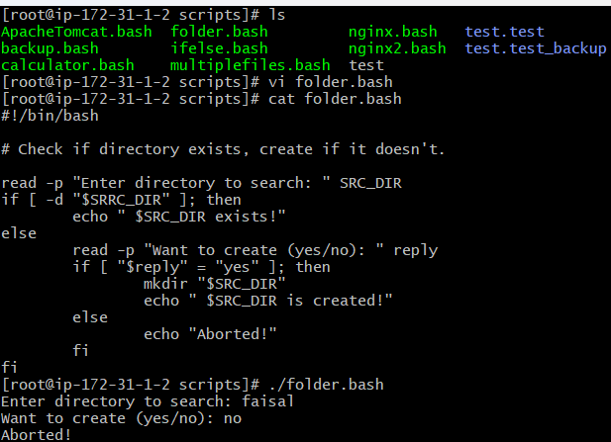
- Create a bash script to delete the last 3 lines of a file
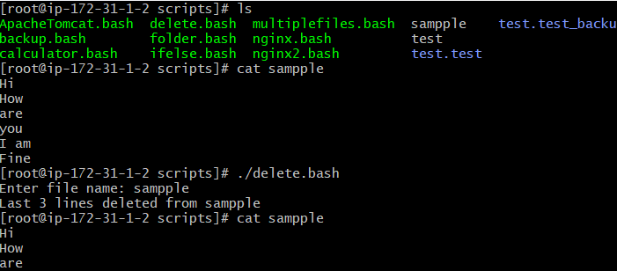
- Bash script to monitor cpu and if it is more than 80% then send email notification
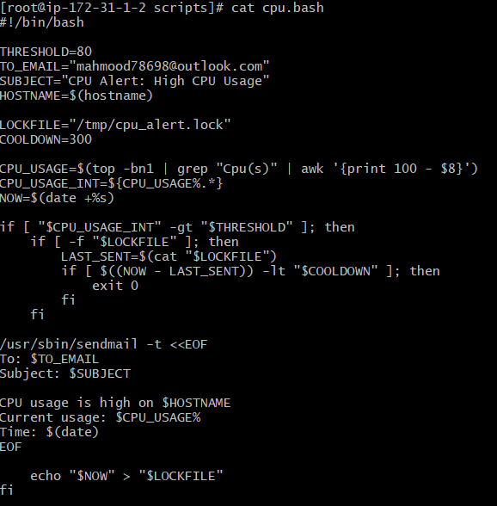
- Bash script to monitor disk space and if it is more than 80% then send email notification
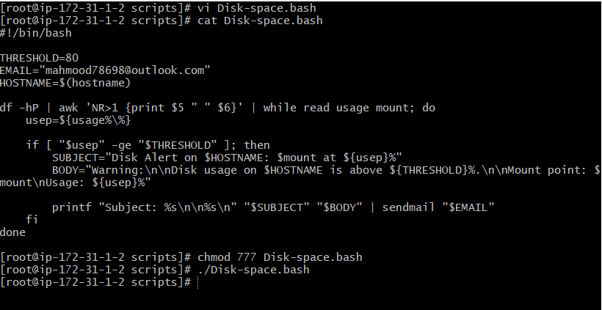
- Bash script to monitor memory and if it is more than 80% then send email notification
